**Day 7 (06 June 2025)**

**112552596 - vsisukhw - Sukhwinder Singh**

**Tasks are given in following file link:**

[**https://docs.google.com/document/d/1FM1fm6s_hRvNG5OKGTZ4CdXrJYLH7C_nTFP0z9SHlpw/edit?tab=t.0**](https://docs.google.com/document/d/1FM1fm6s_hRvNG5OKGTZ4CdXrJYLH7C_nTFP0z9SHlpw/edit?tab=t.0)

**Task 001**

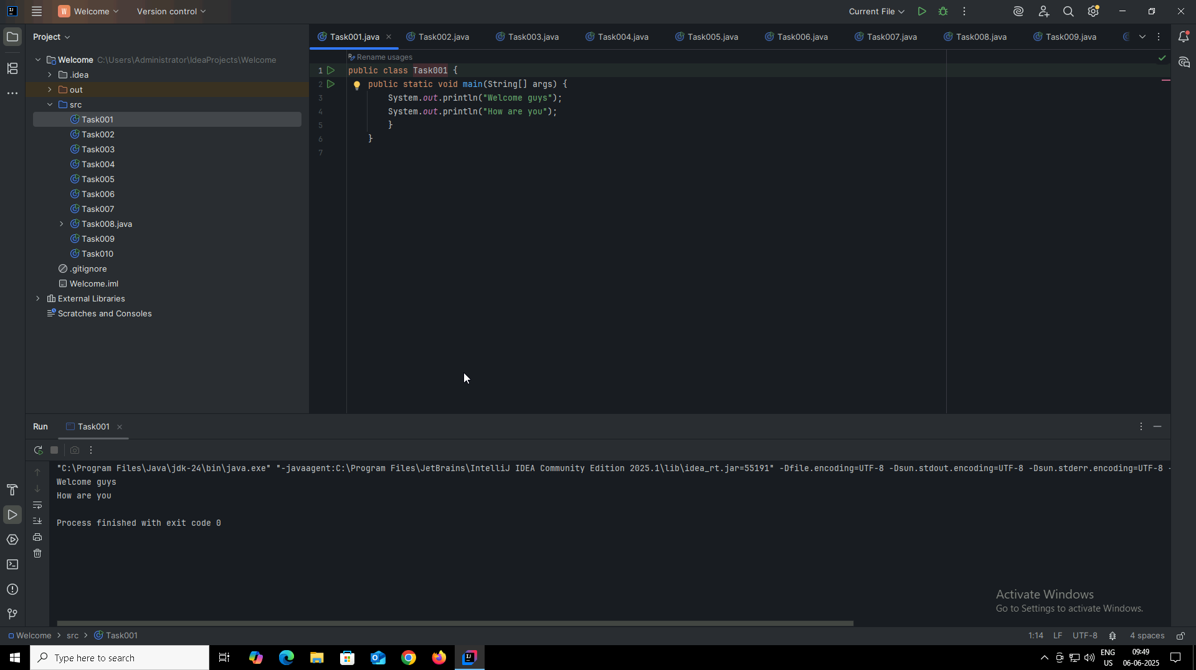

**Task 002**

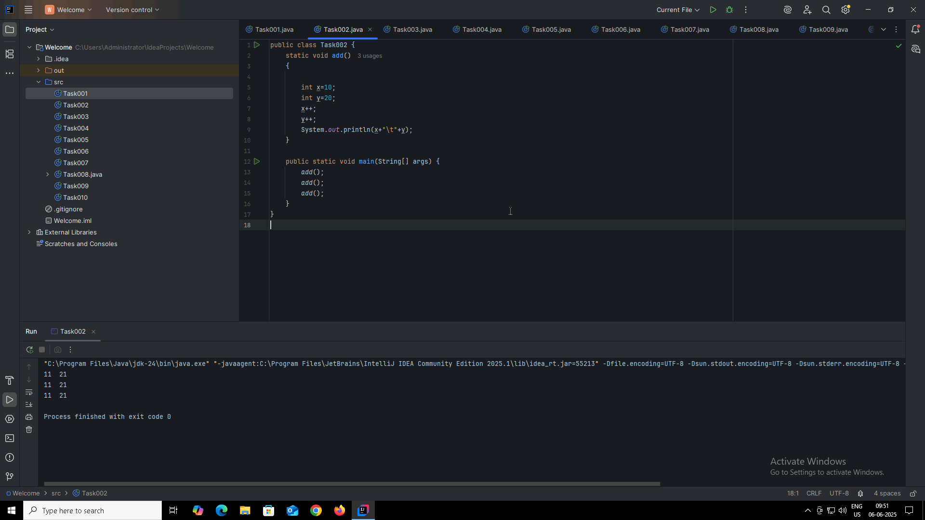

**Task 003**

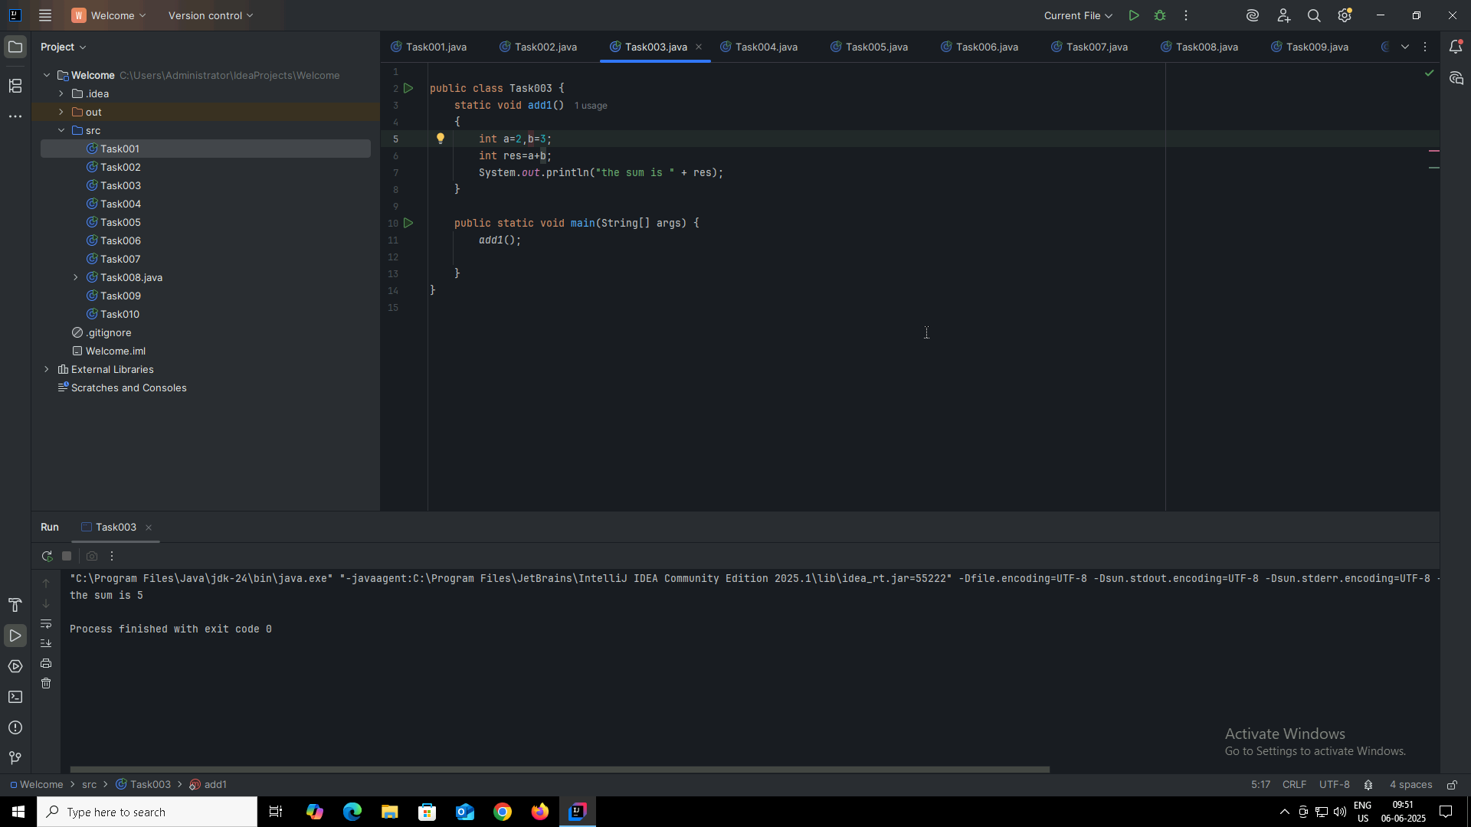

**Task 004**

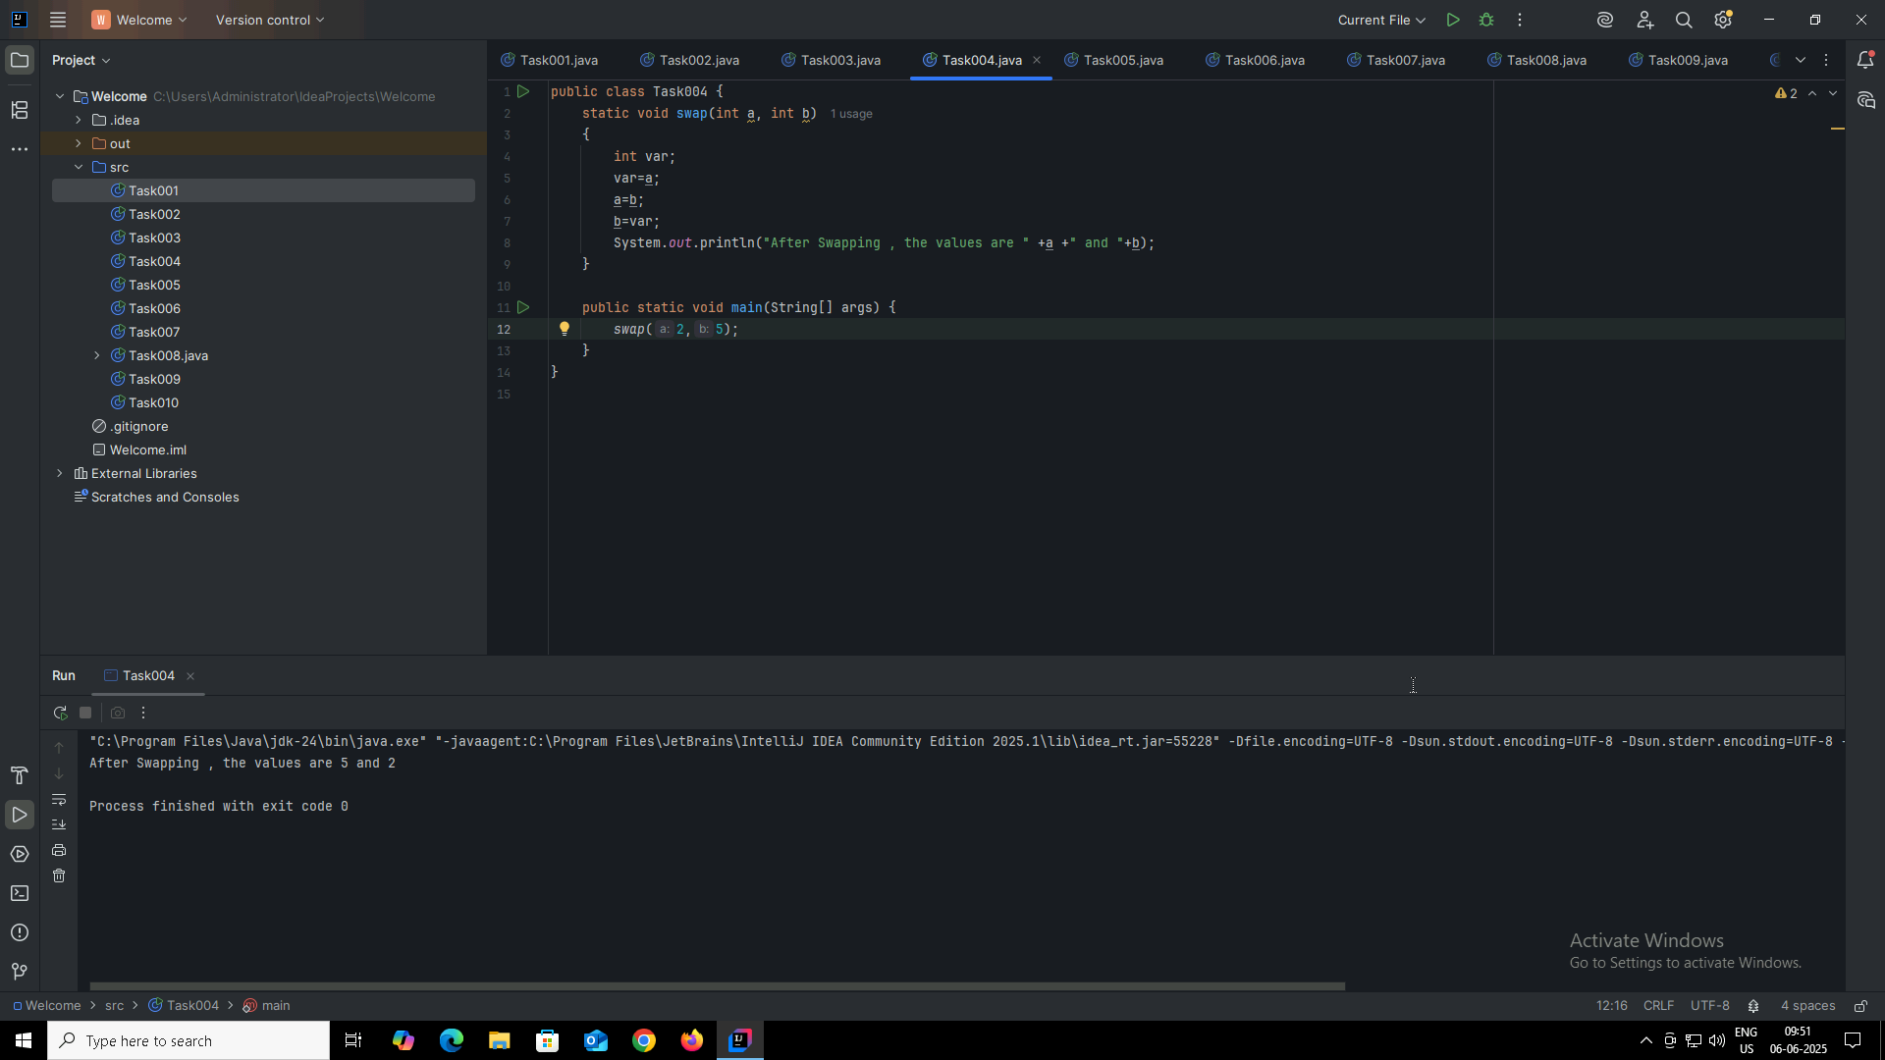

**Task 005**

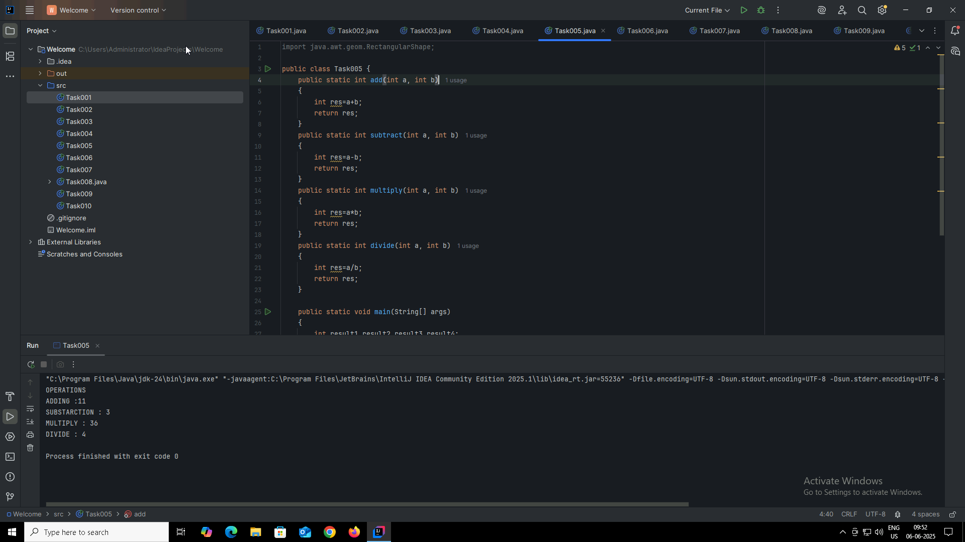

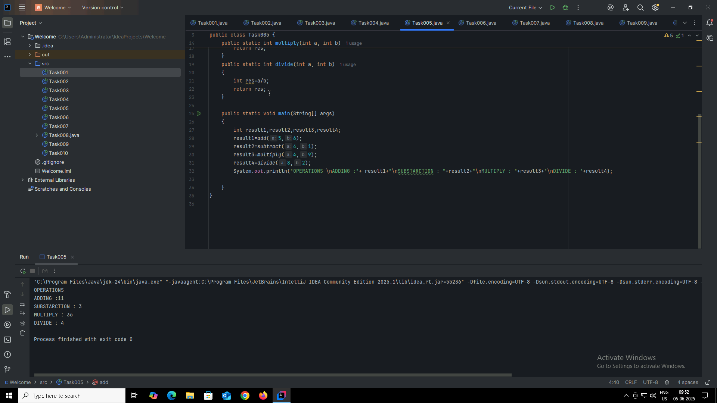

**Task 006**

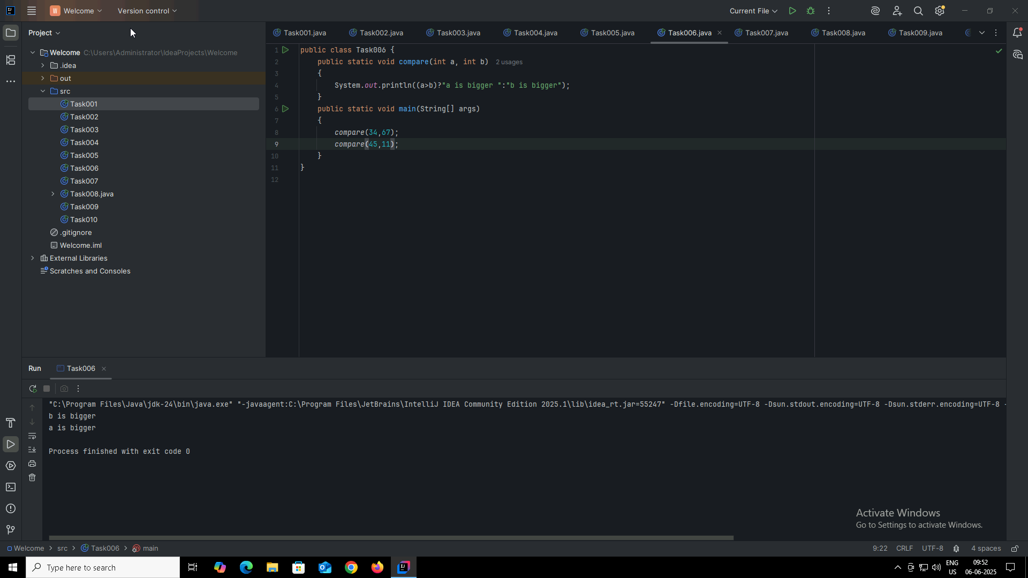

**Task 007**

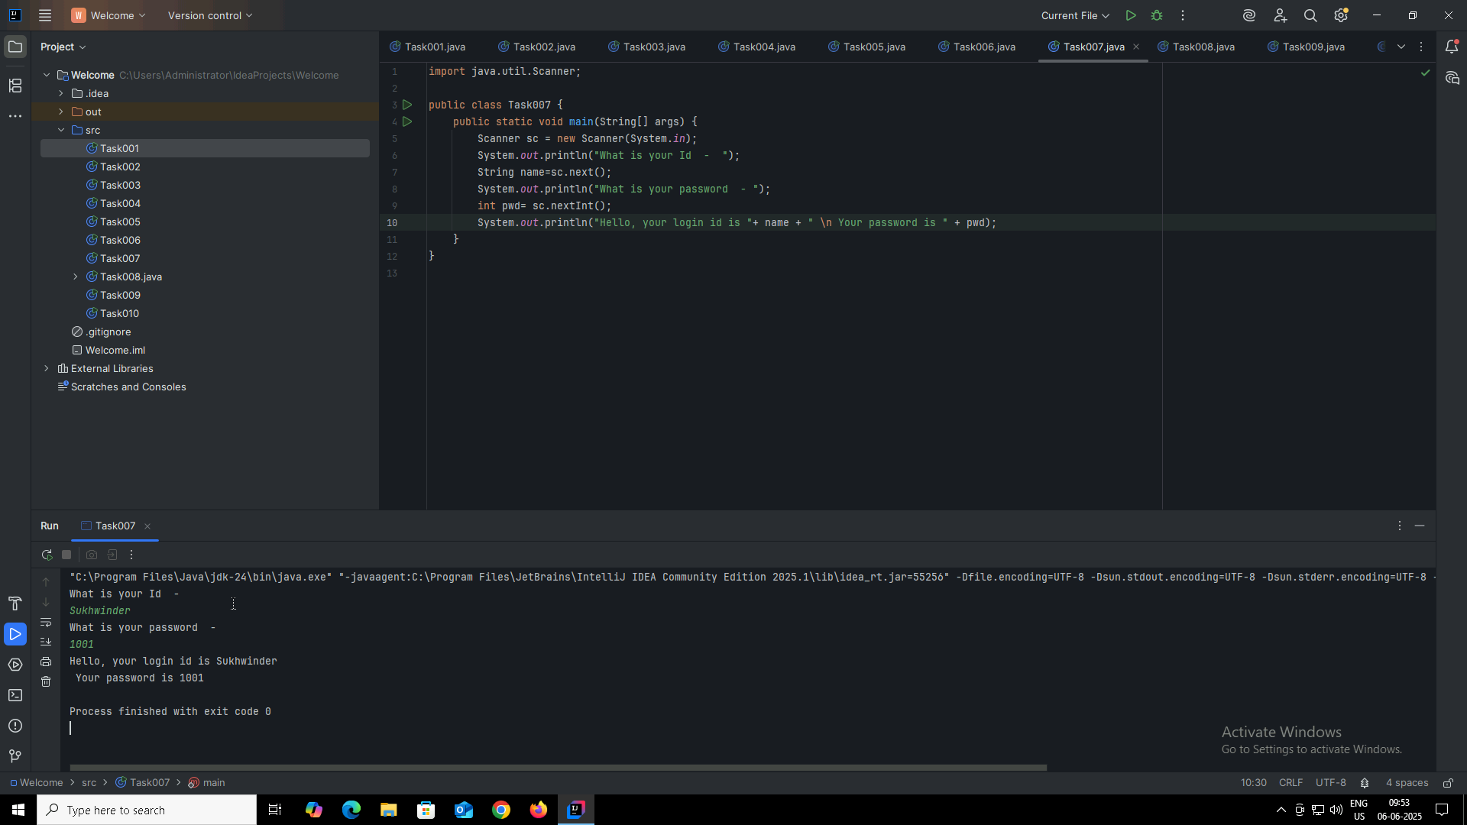

**Task 008**

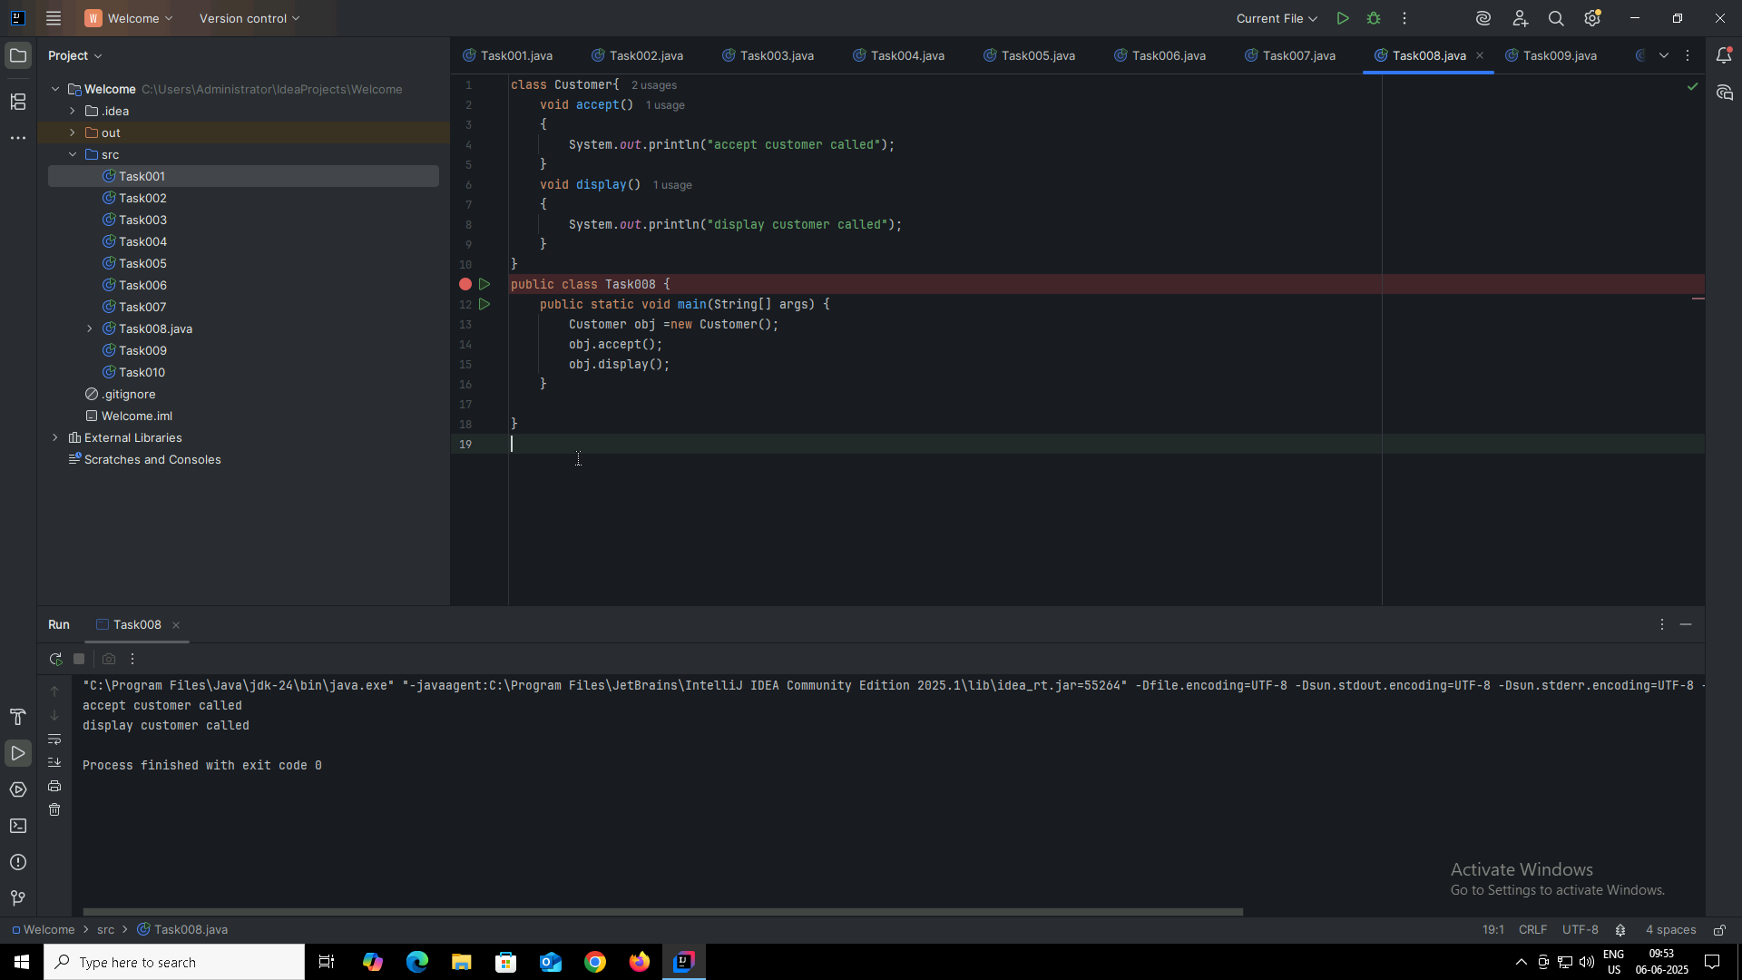

**Task 009**

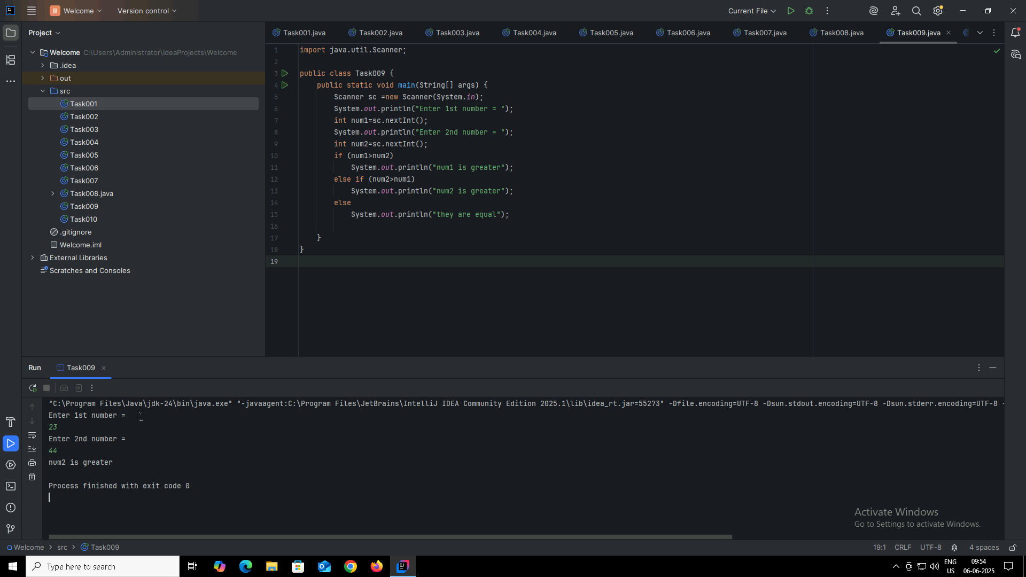

**Task 010**

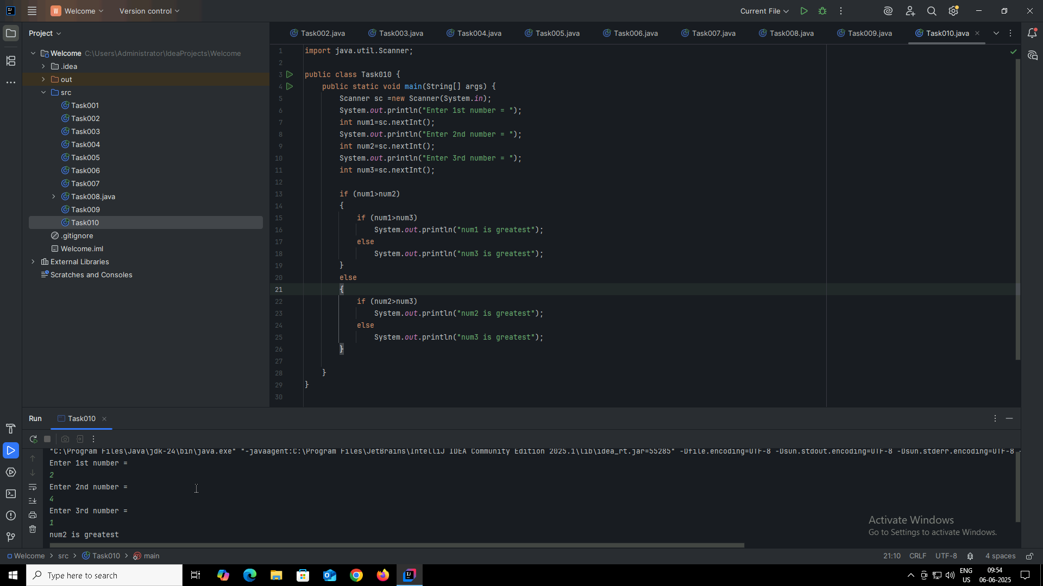

**Task 011**

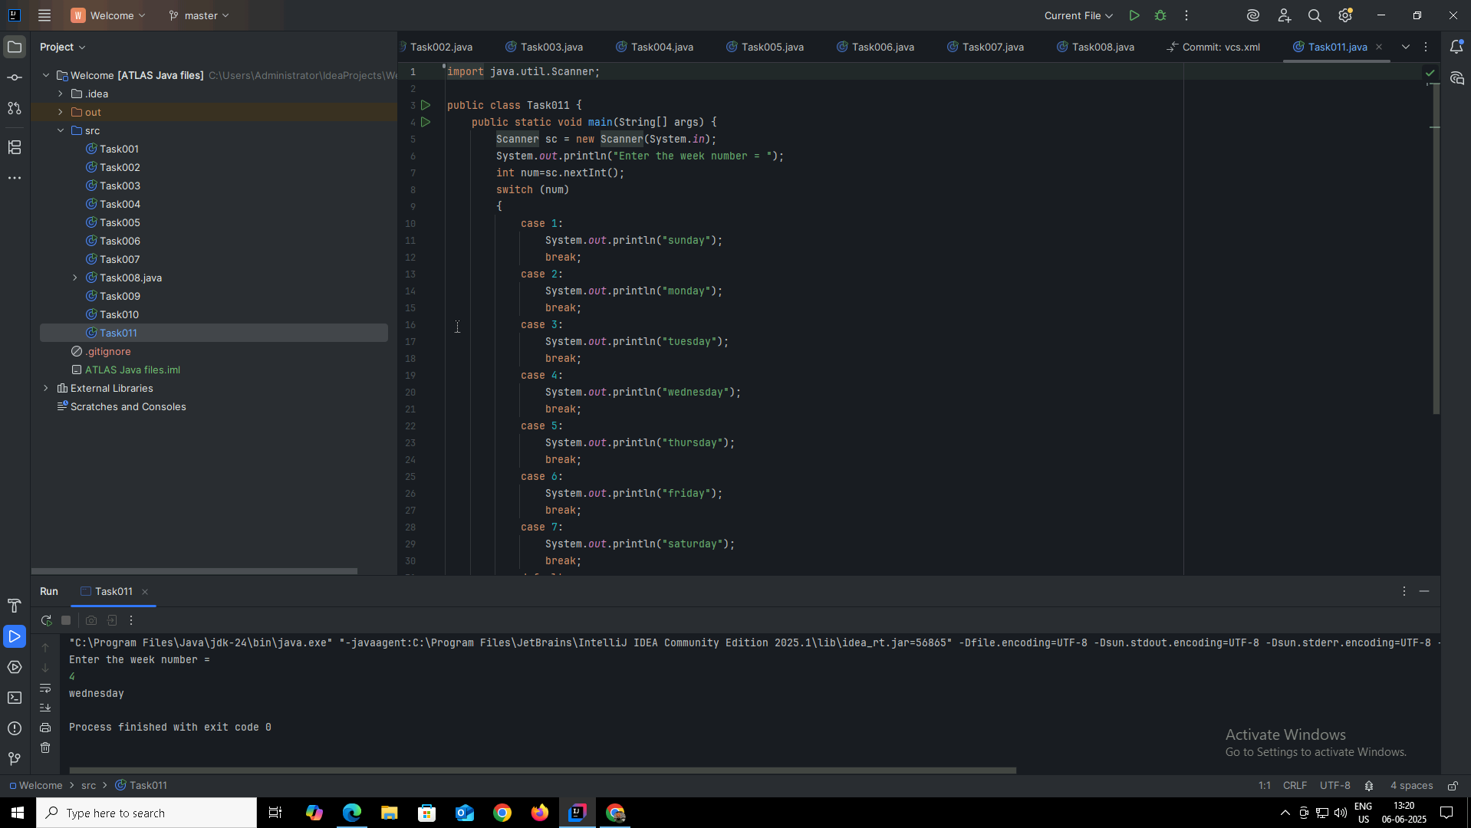

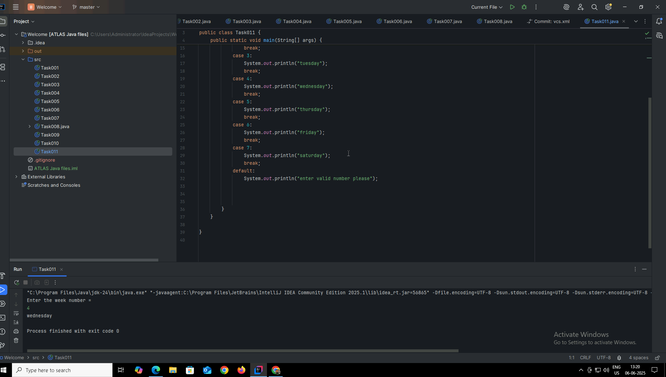

**Task 012**

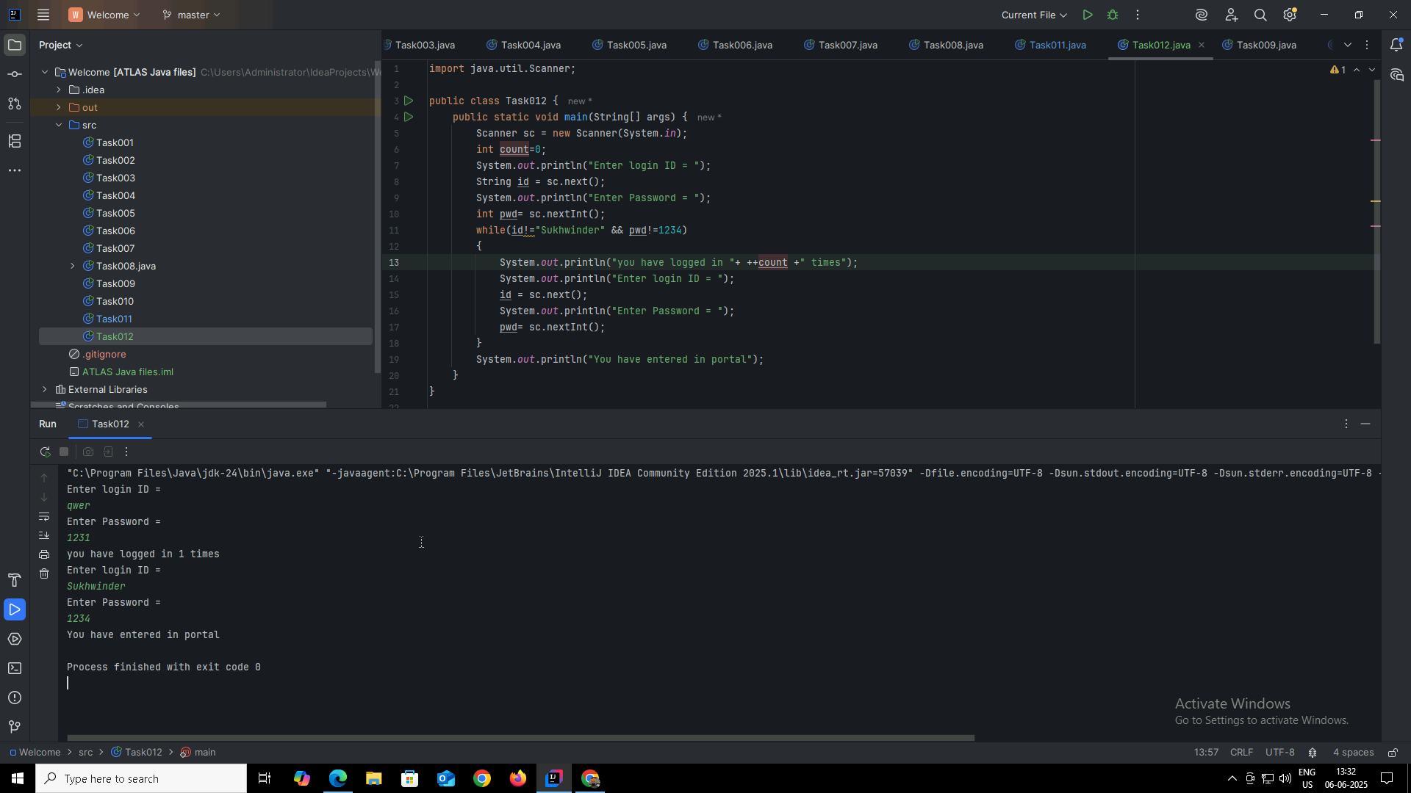

Now, also using this by do-while loop for portal 2..

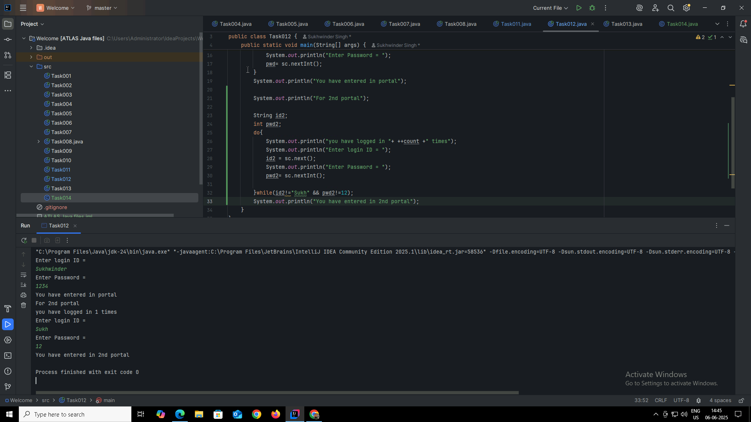

**Task 013**

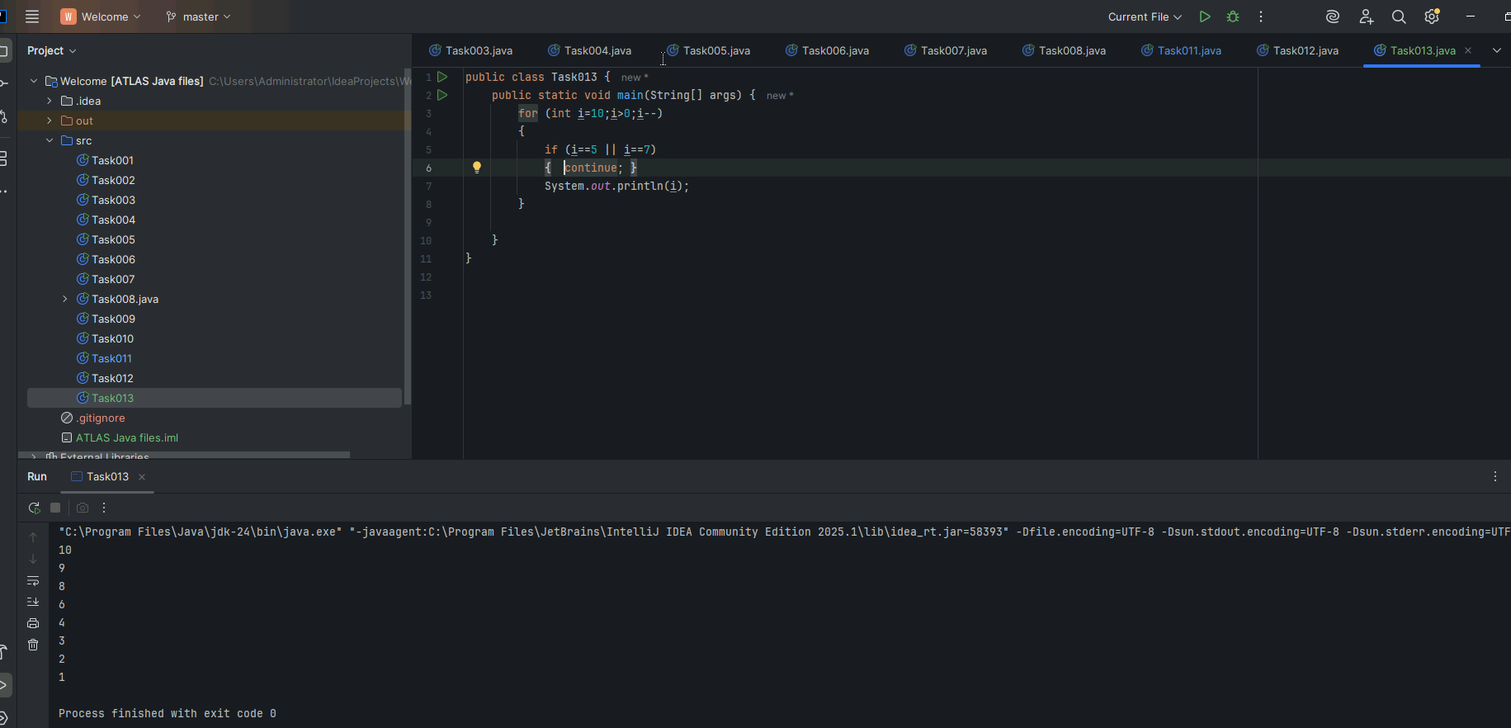

**Task 014**

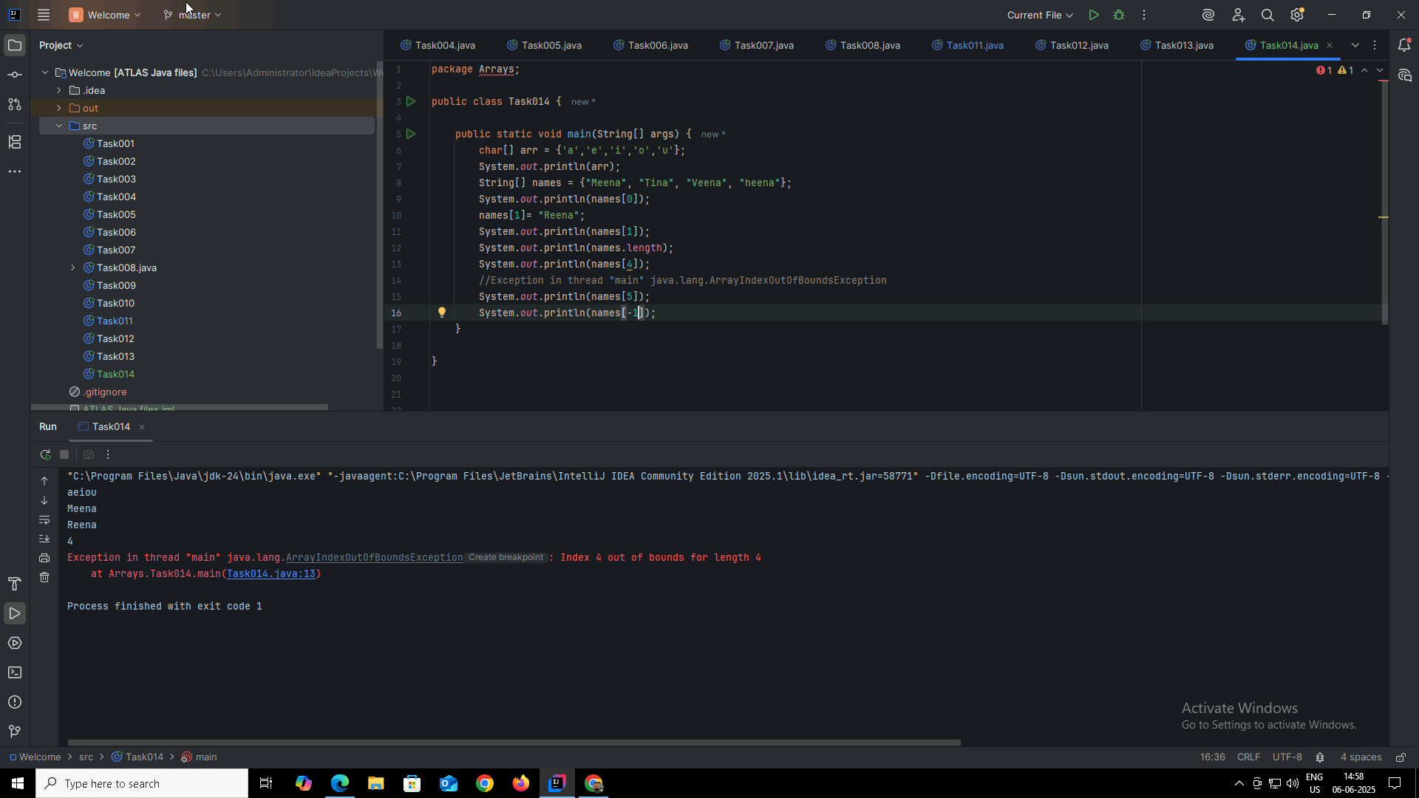

**Task 015**

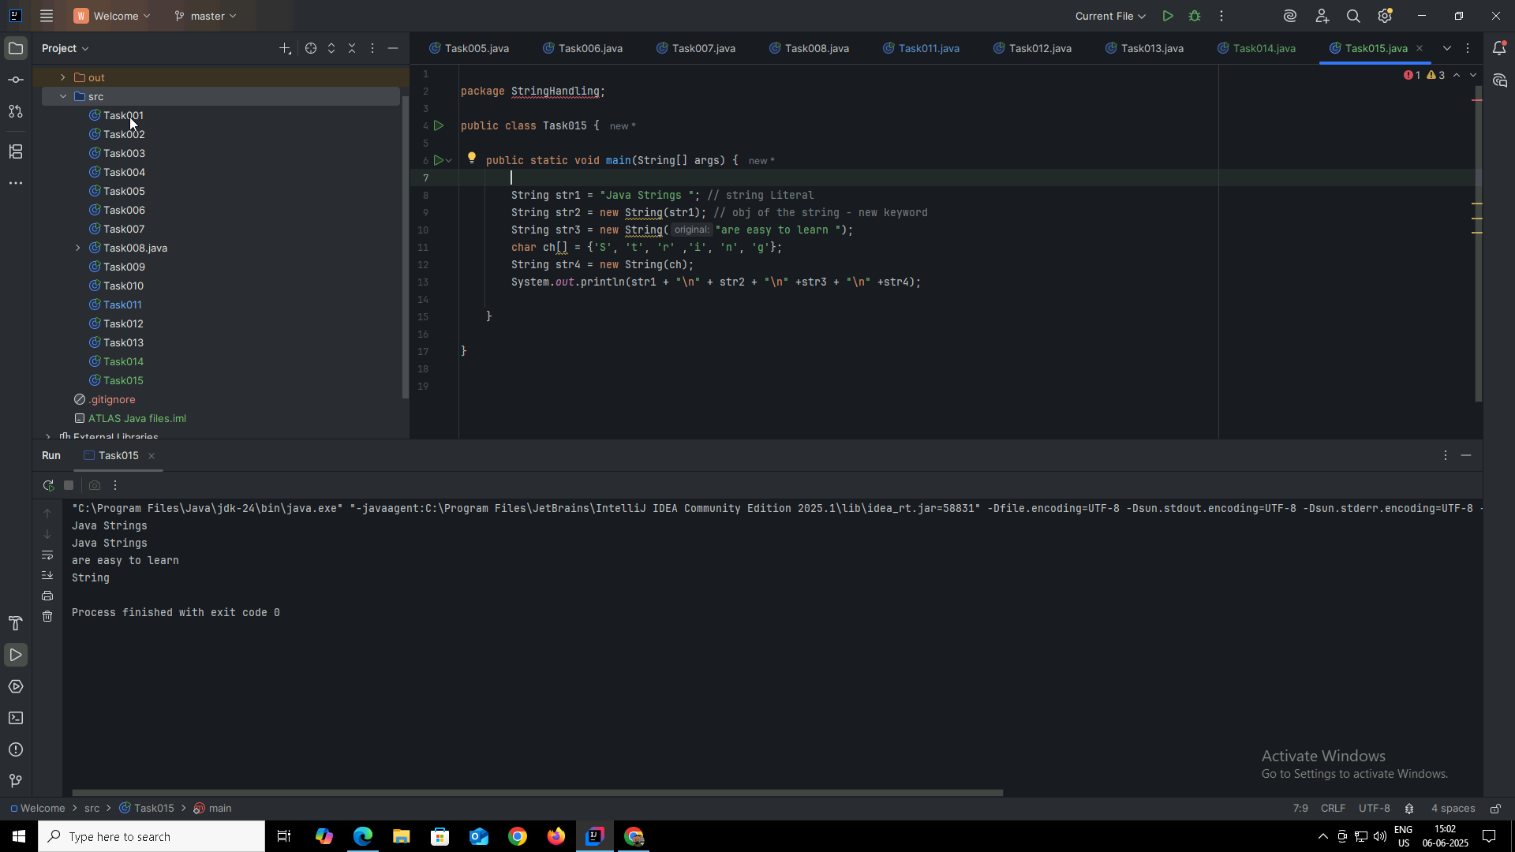

**Task 016**

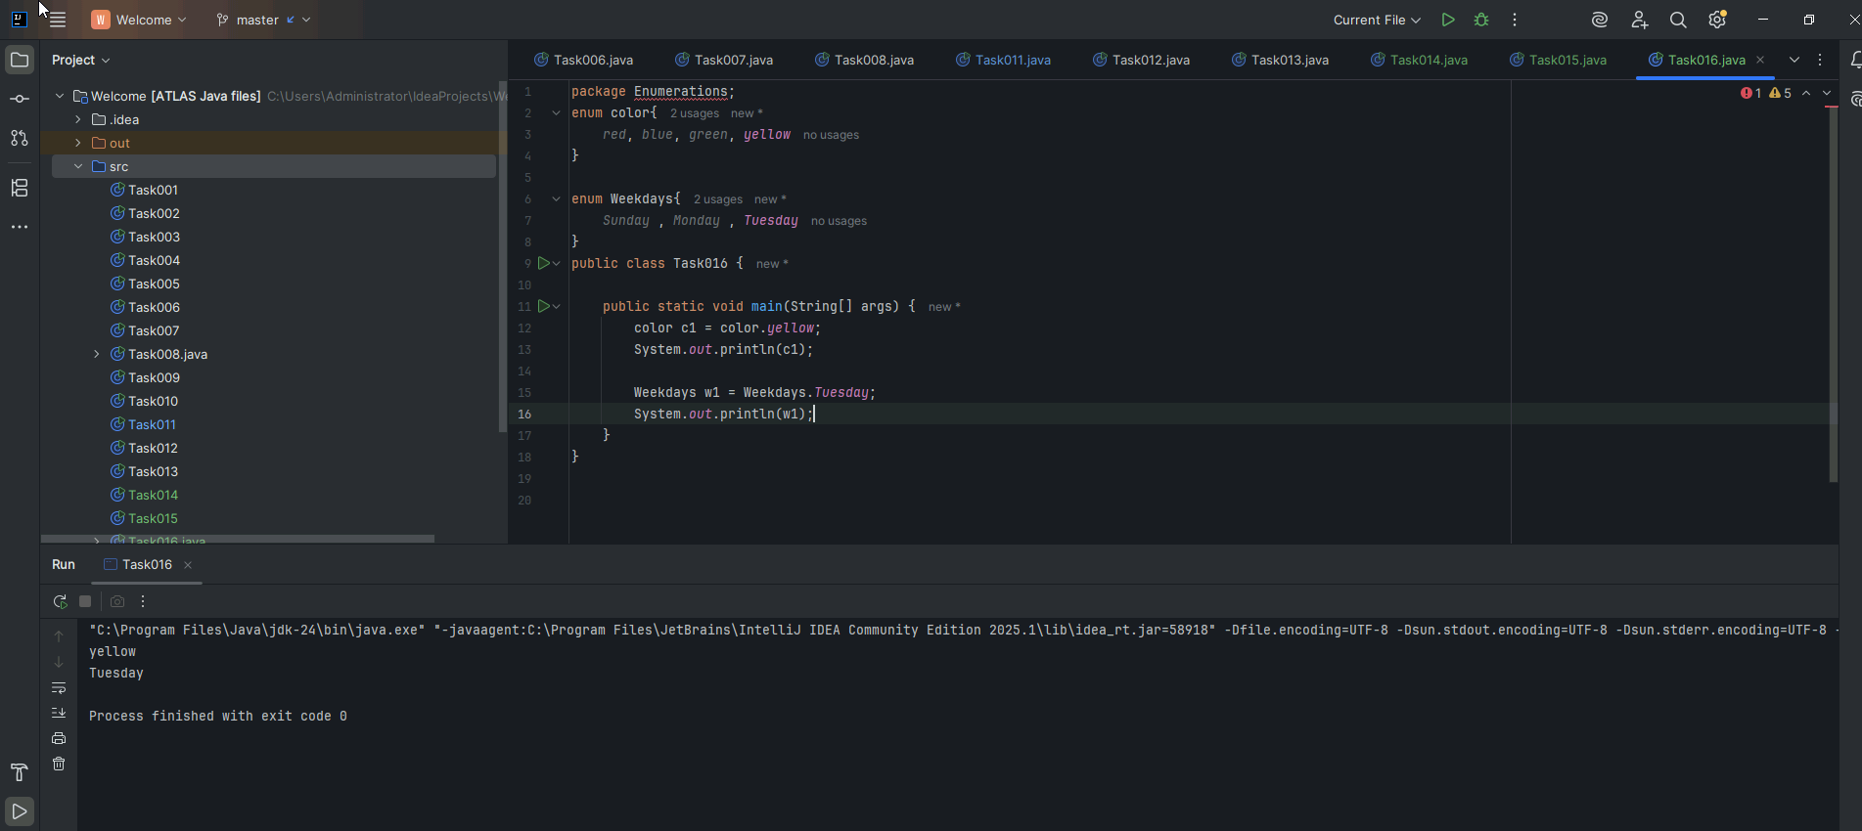

**Task 017**

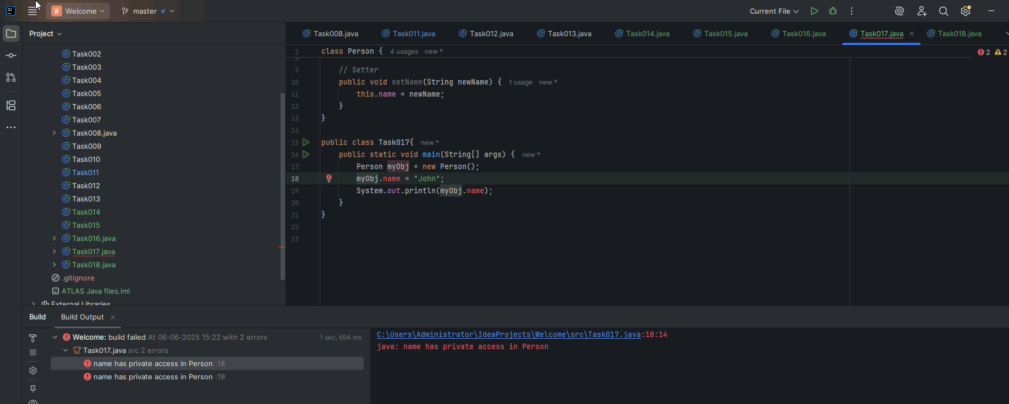

This will show error because “name” variable is private, we cant access them simply by creating object , we have to create getter and setter method to access that. It is shown in Task 18

**Task 018**

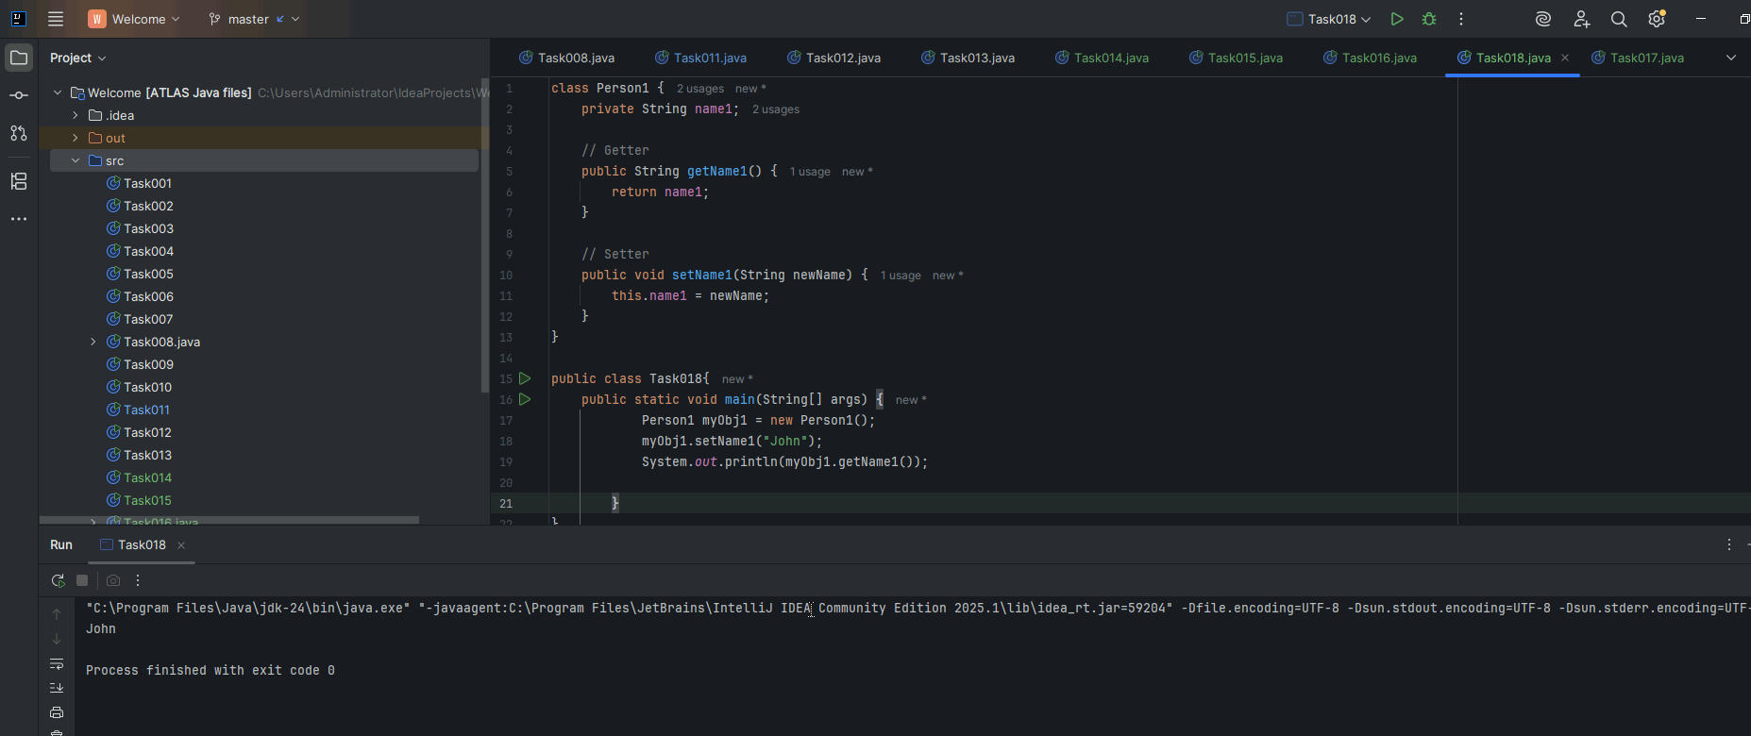

**Task 019**

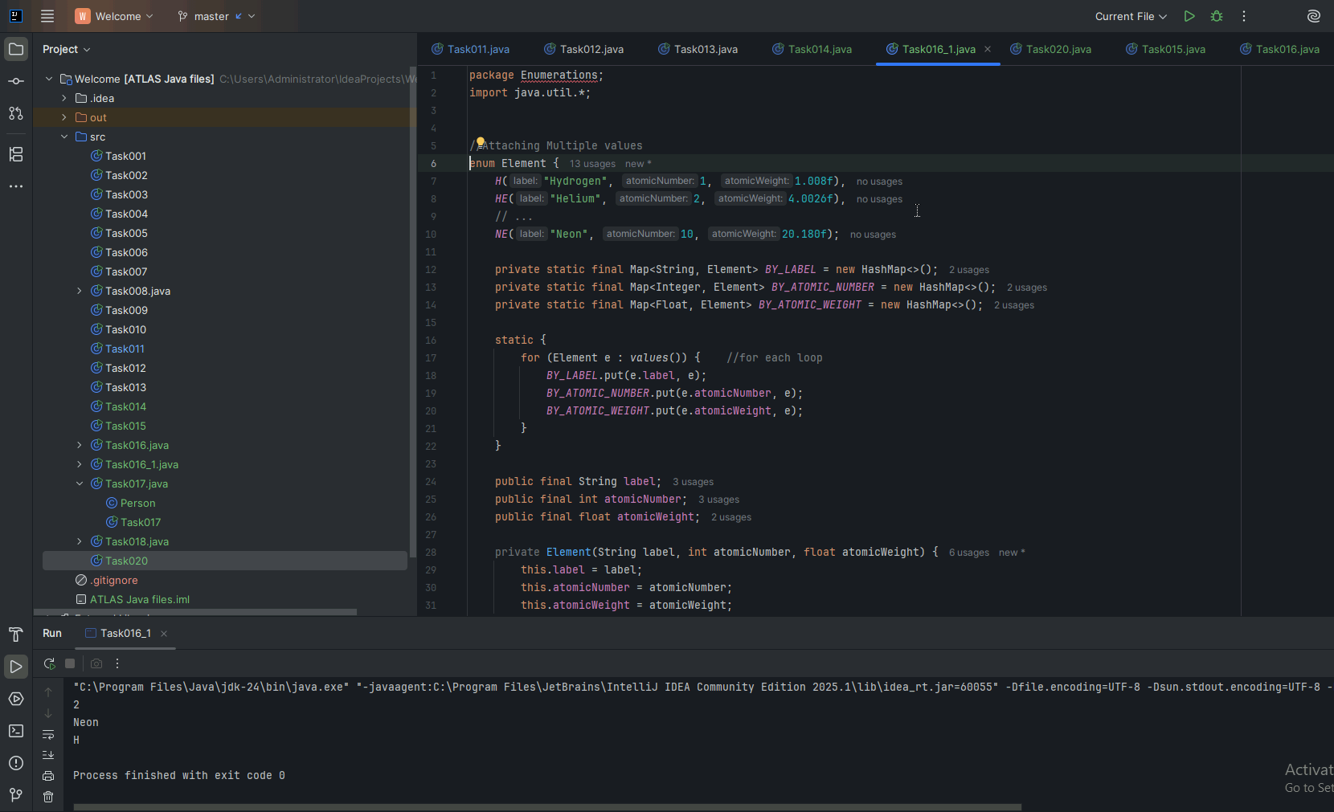

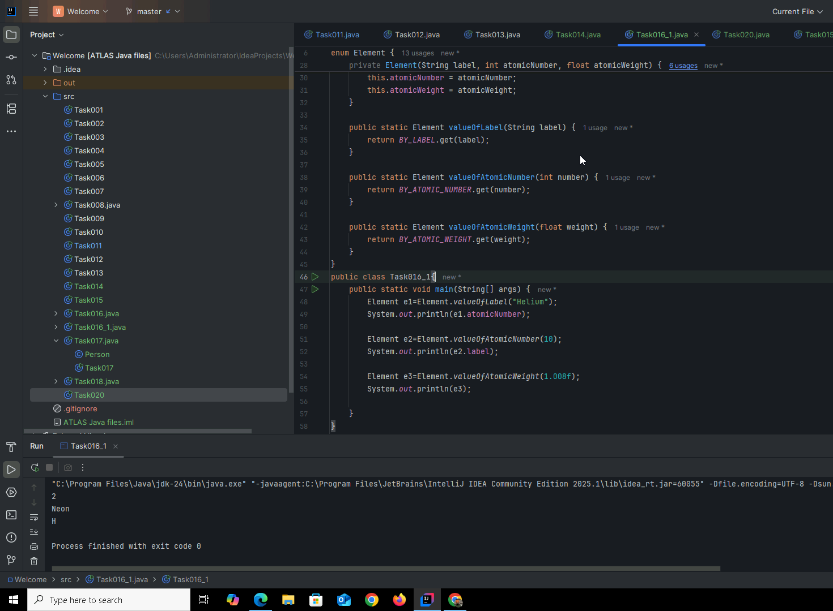

**Task 020**

